9Order Of Service

Singing: Psalm 118—CW page 108

Reading: Psalm 105:23-45

Opening Hymn: TLH 436

Reading: Hebrews 2:1-18

Request Hymn: CW Supplement 752

Reading: Luke 7:1-10

Sermon Hymn: TLH 23

Sermon Text: Acts 7:44-50

Jesus - David - Solomon

Prayer

The Apostles’ Creed, TLH page 12

Holy Communion

The Lord's Prayer

The Blessing

Closing Hymn: TLH 50

************

Bible Study: Lambs: Cheetah
Sheep: Deut: 12:26-32
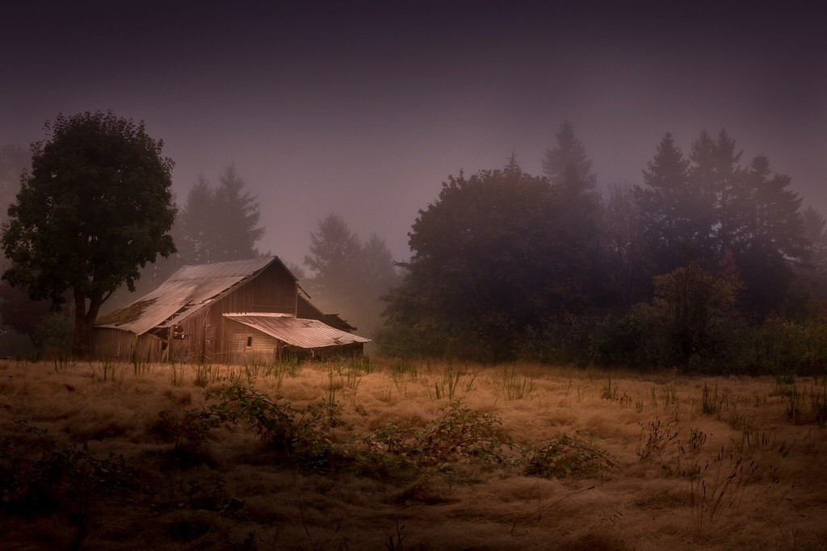

Fall Morning In Fog

Water
Of
Life

25 August 2024

W A T E R O F L I F E

Independent Christian Church—Conservative Lutheran Doctrine

Worship Service: 9:30 a.m.

Larry Cooper, Pastor E-Mail address:
lcooper@wateroflife.cc
Web Site:
www.wateroflife.cc

* * * * * * * * * * * * * * * * * * * * * * * * * * *

Sermon Text: Acts 7:44-50

Jesus - David - Solomon

* * * * * * * * * * * * * * * * * * * * * * * * * * *

44 Our fathers had the tabernacle of witness in the wilderness, as he had appointed, speaking unto Moses, that he should make it according to the fashion that he had seen.
45 Which also our fathers that came after brought in with Jesus into the possession of the Gentiles, whom God drave out before the face of our fathers, unto the days of David;
46 Who found favour before God, and desired to find a tabernacle for the God of Jacob.
47 But Solomon built him an house.
48 Howbeit the most High dwelleth not in temples made with hands; as saith the prophet,

49 Heaven is my throne, and earth is my footstool: what house will ye build me? saith the Lord: or what is the place of my rest?
50 Hath not my hand made all these things?

